**CMP 418 – Multicore Computing**

**Fall 2018**

**Project Proposal**

**Name: Omar Alhammadi**

**ID:62027**

**Date: 12/11/2018**

Project

My project would implement an ECS with automatic game logic parallelizing. An Entity Component System (ECS) that is commonly used in game engines. In an ECS (figure 1), entities are composed of various components. An example would be an enemy with a certain position, velocity, sprite, and health. Essentially, entities are just indexes that own the various components being store in a straight array. Finally, another aspect of the ECS are Systems, which operate only on entities that match the required components of the system. I have previously implemented such system, but the implementation was not parallel.

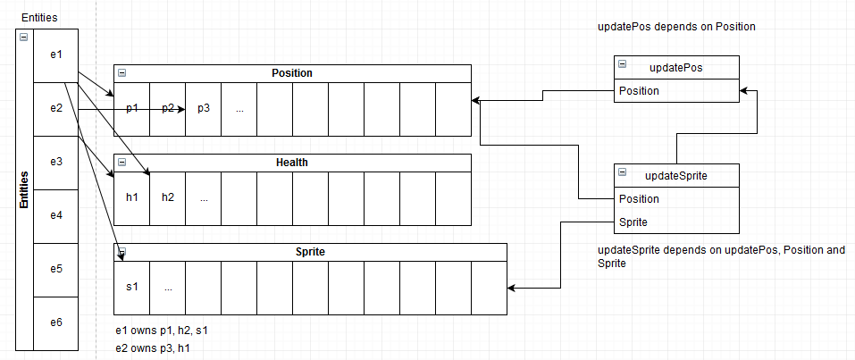

Figure ECS representation

The project would calculate the speed up and efficiency of parallelizing such system by simulating thousands of entities with various components and systems.